St Clare’s Catholic Primary School
Following in the footsteps of Jesus

Special Educational Needs and Disabilities (SEND) Policy

Signed by:
 | Headteacher | Date:
 | Chair of governors | Date:

Last updated: September 2022

St Clare’s Catholic Primary School values the abilities and achievements of all its pupils and is committed to providing, for every pupil, the best possible environment for learning. We recognise that many pupils will have special needs at some time during their school life. This policy should be read in conjunction with the school’s Behaviour and Curriculum policies.
Whilst many factors contribute to the range of difficulties experienced by some children, we believe that much can be done to overcome them by parents, teachers and pupils working together. At St Clare’s we have adopted a whole-school approach to SEND policy and practice. Pupils identified as having SEND are, as far as is practicable, fully integrated into mainstream classes. Every effort is made to ensure that they have full access to the National Curriculum and are able to contribute to all aspects of the school.

Aims
At St Clare’s Catholic Primary School we will ensure that:
- all pupils have equality of access to a broad and balanced curriculum which is differentiated appropriate to their needs and ability
- all pupils have access to Quality First Teaching
- pupils requiring special provision are identified as early as possible
- reasonable adjustments will be made to suit the needs of the children
- pupils identified with special needs take part in all school activities
- parents of pupils with special needs are kept fully informed of their child’s progress and attainment
- pupils are involved, where possible, in decisions affecting their provision

Definition of Special Educational Needs and Disabilities
The definition of special educational needs is set out in section 14 of the SEND Code of Practice (2014):
A child of compulsory school age or a young person has a learning difficulty or disability if they :
- have a significantly greater difficulty in learning than the majority of others of the same age, or
- have a disability which prevents or hinders them from making use of facilities of a kind generally provided for others of the same age in mainstream schools.
Special educational provision means educational provision which is additional to, or different from, the educational provision made generally for children of the same age in maintained mainstream schools. Children must not be regarded as having learning difficulties solely because their language, or their home language, is different from that in which they are taught.
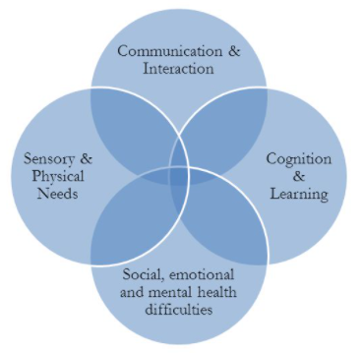
There are four broad areas of need of special education need, these are:
- communication and Interaction
- cognition and Learning
- social, emotional and mental health difficulties
- sensory and/or physical needs

Identification, Assessment and Provision
All teachers are responsible for identifying pupils with SEND and, in collaboration with the SEND lead (SENDco), will ensure that those pupils requiring different or additional support are identified at an early stage.
Early identification:
Early identification of pupils with SEND is a priority. The school will use appropriate screening and assessment tools, and ascertain pupil progress through:
- evidence obtained by regular teacher observation/assessment
- comparisons with National Curriculum expectations
- pupil progress information
- information and support from outside agencies
- information from parents
- standardised screening or assessment tools
As a result of these the school will:
- provide Quality First Teaching strategies for all children
- identify the pupils needs and provide support within the class
- involve parents/carers in a home-school learning approach
- ensure regular feedback on pupil progress through ongoing observations and assessments
- ensure appropriate targets are set and learning experiences enable pupils to meet targets set.

Waves of intervention
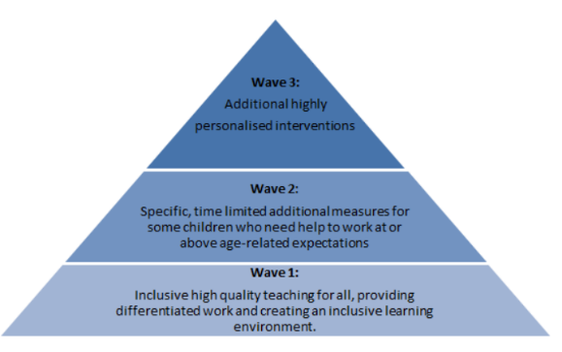
Quality first teaching is the provision that all children have in class. Through rigorous monitoring and assessment, training and resources, the teachers at St Clare’s Catholic Primary School ensure that all children receive quality first teaching (known as wave 1).
As part of St Clare’s Catholic Primary School’s assessment cycle, vulnerable children are identified.
These are children who are;
- not making adequate progress
- working below age related expectations
- not on track for their end of key stage targets
Class action plans enable staff to identify difficulties in learning and put in place a range of measures to address these and bring children ‘back on track’ (these measures are described as wave 2)
Wave 2 provision could be:
- additional support in class from the class teacher, providing a differentiated curriculum
- in class support for groups of pupils by a Teaching Assistant
- periods of withdrawal to work with a Teaching Assistant using a published support programme
- additional in class activities/resources pertinent to need
- increased use of technology (computer programmes)
- peer support/buddy systems
- differentiated homework and support advice for parents/carers

Wave 3:
School support is characterised by interventions that are additional to or different from the normal differentiated curriculum (known as Wave 3). School support intervention is triggered when despite receiving differentiated teaching and support, pupils:
- make little or no progress
- demonstrate difficulty in developing literacy/numeracy skills
- show persistent social, emotional and/or mental health difficulties which are not affected by the school’s support strategies
- have sensory/physical problems, and make little progress despite the provision of specialist equipment
- experience communication and/or interaction problems and make little or no progress despite experiencing a differentiated curriculum

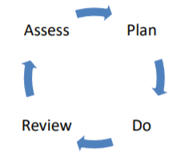
Graduated response
‘High quality teaching that is differentiated and personalised will meet the individual needs of the majority of children and young people.’ (Code of Practice, 2014: 1.24)
The SEN code of Practice advocates a graduated response to meeting pupils’ needs using an: assess, plan, do and review cycle. If teachers have concerns following wave 2 support, children will begin to receive ‘School Support’. At this point, parents/carers will work with the school to set appropriate short term targets and the children will be added to the SEND register at school.
Assessment:
At our school, children’s progress and attainment are assessed regularly. This might happen informally during lessons or more formally through reading assessments, teachers’ marking, assessed pieces of work and class tests. Data for all children is analysed on a half-termly basis and action plans drawn up to support individuals on the basis of this. In addition, there is regular communication with parents which allows for concerns to be raised and addressed early on.
This assessment will be reviewed regularly, on average at least each half term. This will help ensure that support and intervention are matched to need, barriers to learning are identified and overcome, and that a clear picture of the interventions put in place and their effect is developed. For some types of SEN, the way in which a child responds to an intervention can be the most reliable method of developing a more accurate picture of need.

Plan:

Where it is decided to provide a child with SEN support, parents are formally notified, although parents will have already been involved in forming the assessment of needs as outlined above. The teacher and the SENDCo will agree in consultation with the parent and the child the adjustments, interventions and support to be put in place, as well as the expected impact on progress, development or behaviour, along with a clear date for review.

All teachers and support staff who work with the child will be made aware of their needs, the outcomes sought, the support provided and any teaching strategies or approaches that are required. The support and intervention provided will be selected to meet the outcomes identified for the child and will be provided by staff with sufficient skills and knowledge.
Do:
The class teacher will remain responsible for working with the child on a daily basis. Where the interventions involve group or one-to-one teaching away from the main class or subject teacher, the teacher will still retain responsibility for the child. They will work closely with any teaching assistants or specialist staff involved, to plan and assess the impact of support and interventions and how they can be linked to classroom teaching.
Review:

The effectiveness of the support and interventions and their impact on the child’s progress will be reviewed in line with the agreed date. The impact and quality of the support and interventions will be evaluated with Individual Education Plans (IEPs), Annual Reviews, termly meetings and Provision Maps, along with the views of the child and their parents. This will feed back into the analysis of the child’s needs. The class teacher, working with the SENDCo, will revise the support in light of the child’s progress and development, deciding on any changes to the support and outcomes in consultation with the parent and child.
Pupil Support Plan
Pupils receiving school support will have individual support plans. The plans will contain:
  - pupil information
  - attainment and progress data
  - short term targets
  - provision and tracking
  - any external agency support

External Support Services
Parental consent will always be sought when the school seeks external support.
External support services will require access to pupils’ records in order to understand the strategies employed by the school. The specialist may work directly with the pupil and may provide or ask for further assessments. Advice from external support will be incorporated in the child’s targets and will follow the: assess, plan, do, review cycle. Strategies advised may be implemented by the class teacher, teaching assistant or involve other adults. Where appropriate, the school may request direct support/intervention from a specialist/teacher.

Additional Funding
Some pupils with SEND require additional funding in order to provide them with the level of support required to make progress. If this is the case, the SENDco, with class teachers and parents, will complete the paperwork required for additional ‘Top Up Funding’ known as ‘Element 3 high needs’ funding.’ This must show that school is already providing 15 hours of support weekly from the budget (known as element 2 funding).
The Local Authority will decide whether Additional Funding is needed. Where top up funding is allocated, the school must meet the requirements set by the Local Authority. This funding is reviewed annually.
Education Health and Care Plans (EHCP)
The school will request a Statutory Assessment from the Local Authority when, despite an individualised programme of sustained intervention, there remains a significant cause for concern. From September 2014 this statutory assessment may result in and Education and Health Care Plan (EHCP). Prior to this children may have been given a Statement of Special Educational Needs.
A statement of Special Educational Needs and EHCP’s are legal documents and the school must ensure that the requirements set out in them are met.
Statements/EHCPs are reviewed annually, with the year 5 review indicating provision required at secondary school.
More information can be found on the Live Well website: https://www.livewell.cheshirewestandchester.gov.uk/Categories/3948

Allocation of Resources
The Governing Body will ensure that resources are allocated to support appropriate provision for all pupils and to meet the objectives set out in the policy. The school will receive additional funding directly from the Local Authority for children with an Education and Health Care Plan or in receipt of ‘Element 3 top up funding’.

Partnership with Parents and pupils
St Clare’s Catholic Primary school believes in developing strong partnerships with parents and recognises that by working together home and school can help children with SEND achieve their potential.
The school considers parents of children with SEND valued partners in this process and will keep them fully informed and seek their views at every stage. St Clare’s Catholic Primary School signpost additional support for families outside of school where possible.
Pupil’s views are always sought and they are a part of the target setting process. Pupils receiving additional funding are included in the annual review process to the best of their ability.

Role of the Class teacher
Class teachers will:
- differentiate teaching to include all pupils
- assess and monitor progress of all pupils, creating action plans for those that are ‘vulnerable’
- identify pupils with SEND and gather supporting evidence
- ensure additional provision for pupils with SEND is planned and implemented
- ensure paperwork is kept up to date (class tracker/individual tracker/IEPs)
- liaise with the SENCO
- develop strong, supportive relationships with parents/carers
- set appropriate targets
- gather the views of pupils with SEND
- be involved in the development of the SEND policy
Role of the SENCO
The SENCO works closely with staff to ensure the school fulfils the aims in this policy. The SENCO works with the Head teacher and Governing Body to determine the strategic development of the policy.
Responsibilities include:
  - coordinating provision for pupils with SEND and recording this in a provision map
  - liaising with and giving advice to teachers and teaching assistants
  - overseeing pupil records
  - liaising with parents
  - contributing to INSET and supporting CPD
  - liaising with external agencies and support services
  - reporting to the Headteacher and Governing Body
  - liaising with the Governor responsible for SEND

The Governing Body
The Governing Body, with regard to the SEND code of Practice, will ensure that:
  - provision of a high standard is made for SEND pupils
  - those involved with teaching and supporting pupils with a statement are kept fully informed
  - SEND pupils are fully involved in school activities
  - they are involved in developing and reviewing the SEND policy
  - parents are informed about the Policy
  - there is an appointed SEND Governor
  - the SEND report is updated annually and available on the school’s website
The Governing body will review data regarding progress and attainment of pupils with SEND to monitor the success of the policy.
The Governing Body will report annually on the success of this policy through liaison with teachers, parents, pupils and external professionals.

